**Barbie Bungee** NAME ___________________________

Group #_________

In this activity, you will simulate a bungee jump using a Barbie® doll and rubber bands.

Before you conduct the experiment, formulate a conjecture:

*I believe that _____ is the maximum number of rubber bands that will allow Barbie to safely jump from a height of 250 cm.*

Now, conduct the experiment to test your conjecture.

**PROCEDURE:**

Complete each step below. As you complete each step, put a check mark in the box to the left.

􀂉 Tape a large piece of paper to the wall from the floor to a height of about six feet.

􀂉 Draw a line near the top to indicate the height from which Barbie will make each jump.

􀂉 Create a double-loop to wrap around Barbie’s feet. A double-loop is made by securing one

rubber band to another with a slip knot, as shown (below).



􀂉 Wrap the open end of the double-loop tightly around Barbie’s feet, as shown (below).



􀂉 Attach a second rubber band to the first one, again using a slip knot, as shown below.



􀂉 With two rubber bands now attached, hold the end of the rubber bands at the jump line with

one hand, and drop Barbie from the line with the other hand. Have a partner make a mark to

the lowest point that Barbie reaches on this jump.

􀂉 Measure the jump distance in centimeters, and record the value in the data table in

Question 1. You may wish to repeat this jump several times and take the average, to ensure

accuracy. Accuracy is important—Barbie’s life could depend on it!

􀂉 Repeatedly attach two additional rubber bands for each new jump, measure the jump

distance, and record the results in the data table.

􀂉 When you’ve completed the data table, answer Questions 2-12.

**1.** Complete the data table below.

|  |  |
| --- | --- |
| # of Rubber Bands  (x) | Jump Distance in cm  (y) |
| 1 |  |
| 2 |  |
| 3 |  |
| 4 |  |
| 5 |  |

**2.** Make a scatterplot of your data. Be sure to indicate the scale on each axis and label.

* The x-axis should go out to 25 rubberbands.
* The y-axis should go out to 250 centimeters.

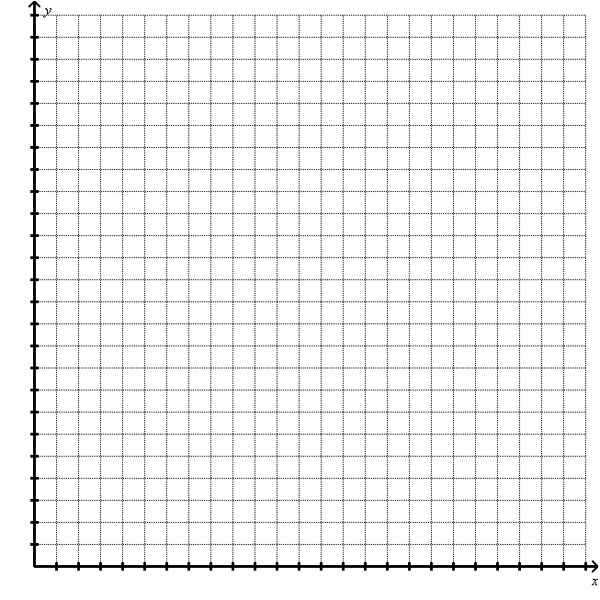

**3.** On the graph above, sketch a line of best fit.

**4.** What is the relationship between the number of rubber bands and jump distance?

**5.** What is the equation for your line of best fit.

You will need to find the __________________ and the ____________________ to write this equation.

**Neatly show all of your work** for finding the slope and the y-incept of the line in the space below:

**6.** What is the slope of your equation, and what does it represent in this context?

**7.** What is the *y*-intercept of your equation, and what does it represent in this context?

**This part should be completed independently.**

**8.** What would be the maximum number of rubber bands that Barbie should use to safely bungee jump from 250 cm? Keep in mind that Barbie wants a thrill so she wants to come as close to the ground as possible without actually hitting the ground. You will make this prediction using two different methods…

* Using your Line of Best Fit: ______________
* Using your Regression Equation: _____________

**(Be sure to show your work for this in the space below.)**

**9.** Are your predictions reliable? Justify your answer. Be sure to consider your methods of

collecting, recording, and plotting data.

**10.** How do your predictions from Question 8 compare to the conjecture you made before doing the experiment?

**This part should be completed with your group.**

11.At this point each member of your group has decided on the number of rubber bands your group should use for the final jump. Your group needs to compare these estimates and arrive at a consensus. Your Barbie may only jump once from your final height so your group must agree on one number of rubber bands.

How many rubber bands did your group decide to use? _______________

In the space below, explain how your group made this decision:

12. **Jump!!**

Successful Jumps: 5 points the jump is within 10 cm

4 points the jump is within 15 cm

3 points the jump is within 20 cm

2 points the jump is more than 20 cm

Unsuccessful Jumps: 2 points Barbie’s head just perfectly touches the ground

1 points Barbie hits the ground with major impact

After Barbie’s jump, **circle the point value that your group earned.**

1. **Reflection Questions…**

If you earned all 5 points on the final jump, answer the following question…

1. What factors contributed to the success of your jump? How was your group able to make such an accurate prediction?
2. If you were to do this project again, is there anything that you would have done differently? If so, what? If not, why not?

If you missed points on the final jump, answer the following questions…

1. Did your group over estimate or under estimate the number of rubber bands needed for the final jump? What are some factors that may have contributed to this mistake?
2. Next time, what would you do differently during the course of the project to avoid these mistakes?

|  |  |  |
| --- | --- | --- |
| **Barbie Bungee Project – Grading Criteria** | | Rubric Score |
| Day 1 | * + The procedures checklist is complete. (1 point)   + All group members work efficiently during the class period. (2 points)   + The data table is accurate. (2 point) | /5 |
| Day 2 | * + The scatter plot includes a title, labels, scales, and data points. (5 points)   + The sketch of the line of best fit is reasonable. (2 points)   + The relationship between the variables is clearly and accurately stated. (2 points)   + The equation of the line of best fit is accurate, based on the data. (5 points)   + The slope and *y*‑intercept are explained in context. (2 points) | /16 |
| Day 3 | * + The predictions are made and their reliability is discussed. (2 points)   + The predictions are compared to the original conjecture. (2 points)   + The predications are mathematically sound. (6 points) | /10 |
| Jump | Successful Jumps: 5 points the jump is within 10 cm  4 points the jump is within 15 cm  3 points the jump is within 20 cm  2 points the jump is more than 20 cm    Unsuccessful Jumps: 2 points Barbie’s head touches ground  1 points Major impact | /5 |
| Day 4 | * + Reflection questions are thoroughly and accurately addressed. | /4 |

Total = __________/40