Final Exam Review Name:____________________
7th Grade Math

- Simplify.

a. –12 + 20 b. 10 – –4 c. –40 + –23

d. 9 ÷ –3 e. (–5)² f. –3²

g. –8 – a h. 10 – a i. –a + –6
if a = –8 if a = –12 if a = –11

j. –4 – a k. –10 ● a l. –3 ● a
if a = |4| if a = |–5| if a = –|3|

- Convert the following to a decimal.
  - $\frac{4}{9}$ b. $6\frac{1}{8}$

- You decide you want to find out how many deer are in your woods in your back yard. You tag 345 deer and release them back in the wild. A year later, you collect a sample of 980 deer, 120 of which are tagged. Estimate the total deer population in that area.

- What is a biased sample? What is a random sample? Which is better?

- A representative sample of 40 junior high students were surveyed about their favorite core class. ELA was chosen by 18 students. Based on this information, how many of the school’s 520 students would you expect to choose ELA as their favorite?

- The scale drawing of the horse below uses a scale factor of 1 inch = 12 inches. Find the actual height of the horse.
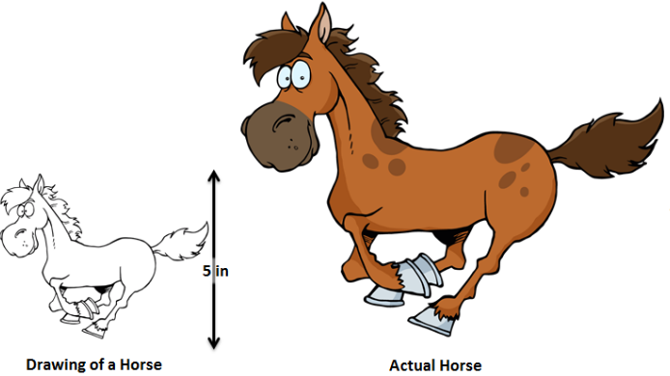

- The image below is a scale drawing of an elephant. It was drawn with a scale of 1 inch = 6 feet. Find the actual length of the elephant in feet.
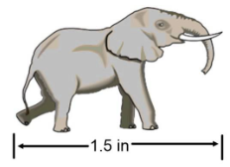

- In a new board game, players have to roll a fair, six sided die and flip a coin.

  - What is the probability that a player will roll the #1 and flip tails in the same turn?

  - What is the probability that a player will roll an even number and flip heads in the same turn?

- A bag contains 3 red marbles, 5 blue marbles, and 9 green marbles?
  - What is the probability of drawing a blue marble?

  - What is the probability of drawing a green marble followed by a red marble without replacement?

- There are 12 people on Kyla’s volleyball team. If the coach is randomly choosing players to lead a drill, what is the probability that Kyla will be chosen two times in a row?

- If I flip a coin 6 times, find the probability that they all will land on heads.

- Juan goes to a fast food restaurant with the following options…
Main Dish | Side Dish | Beverages
Hamburger | Salad | Soda
Hotdog | French Fries | Water
Pizza |  | Juice
Chicken Tenders
Sub Sandwich

- What is the probability that Juan orders a sub sandwich with salad and water?

- List all of the main dish, side dish combinations that can be made from this restaurant. (NOTE: We are NOT factoring in the beverage options for this question.)

- An owner of a small movie theater is gathering data and finds that in the last week there were 102 customers who saw the Disney film, 84 who saw the suspense film, and 67 who saw the romantic comedy. Based on this information what is the probability that the next customer to arrive will want to view the romantic comedy?

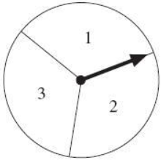

- The spinner pictured to the right was spun 60 times. The results are in the table below…
Number | Outcomes
1 | 28
2 | 20
3 | 12

Based on these outcomes if the spinner is spun 20 more times, how many times will it land on 2 or 3?

- Marie’s wallet has a lot of change in it. The probability of randomly selecting each coin is listed in the table. Which coin is most likely to be selected at random?

Coin | Probability
Penny | $$\frac{4}{9}$$
Nickel | $$\frac{5}{18}$$
Dime | $$\frac{1}{9}$$
Quarter | $$\frac{1}{6}$$

- What is the probability of rolling a 2 or lower on a standard dice?

.
- Use the picture to the right to answer the following:
.
V
Z
.
.
.
- What angle is complementary to <2 ?
2
1
3
- What angle is vertical to <5 ?
T
5
W
Y
4
.
- What angle is supplementary to <3 ?
X
- What 2 angles are adjacent to <5 ?

- What angle is complementary to <5 ?

- What angle is vertical to <4 ?

m<3 = 65°. Write 65° in the picture and use it to answer the following questions. DO NOT use a protractor!

- What is m<1 ? h) What is m<2 ?

- What is m<4 ? j) What is m<5 ?

- Find “x” and the missing angles.

H x = _____________
x – 24
x
P m<H = _____________

m<O = _____________
2x

O m<P = _____________

\

- Using the picture to the right, find m<K
K
32°

- Find the area of and perimeter of the rectangle below…

Area =

Perimeter =

- Find the area and perimeter of the following triangles.

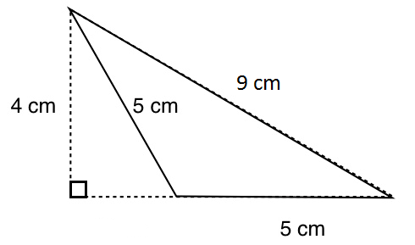
a) b)
9.5 in
8 in
5 in
4 in

AREA PERIMETER AREA PERIMETER

- Find the area and circumference of the circle.

AREA:
13 ft

CIRCUMFERENCE:

- If a circle has a circumference of 64 inches, what would the diameter be?

- Find the area of the shaded region in each figure below...
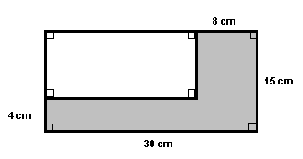

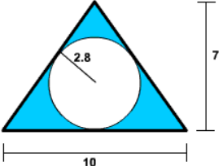

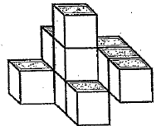
- Which drawing represents the top view of this drawing?

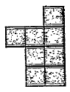
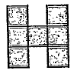
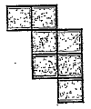
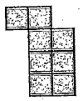
- b) c) d)

- Sketch the shape made by each cross section below…
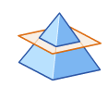
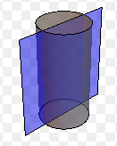
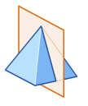
  - b. c.

- Give each triangle below two names (one based on angles and one based on side lengths).

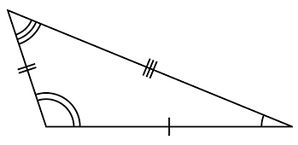
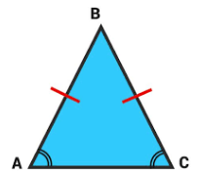
  - b.

___________________________ ___________________________

___________________________ ___________________________

- Name the following figures
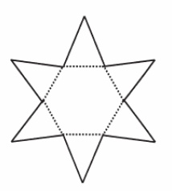
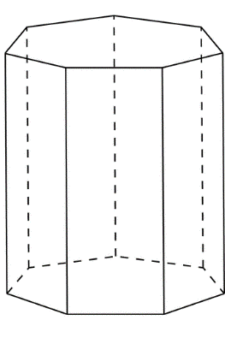
a) b)

- Find the surface area of a cube where each edge is 6 cm.

- Find the surface area AND volume of the following shapes. Show all of your work and include units with your answer!
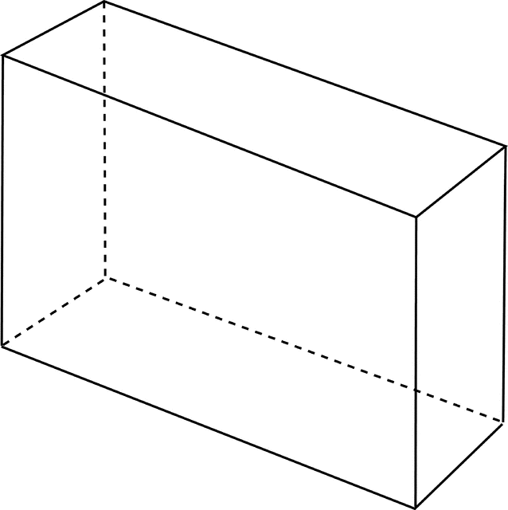
- SURFACE AREA:

36 cm

VOLUME:
12 cm
50 cm

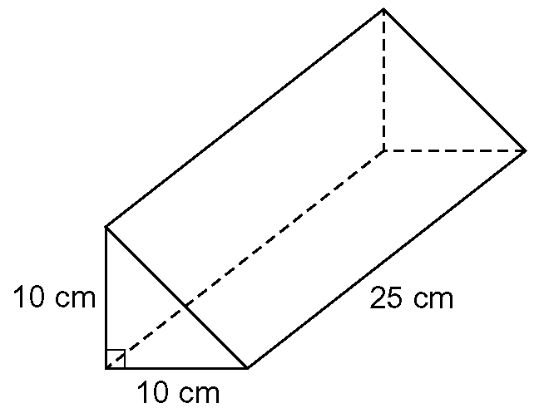
- SURFACE AREA:
14 cm

VOLUME:

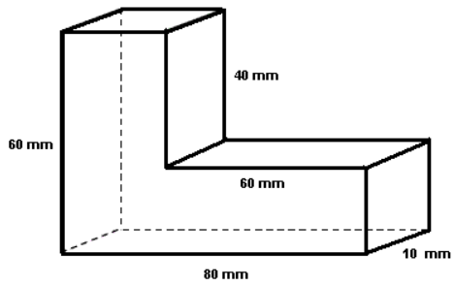
- Find the volume of the figure below…

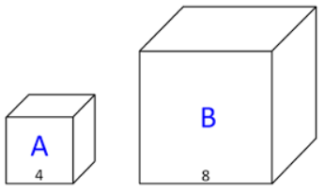
- In the diagram, how much GREATER is the…
  - area of box B than the area of box A?

  - volume of box B than the volume of box A?

Answers
1. a. 8 b. 14 c. -63 d. -3 e. 25 f. -9 g. 0
h. 22 i. 5 j. -8 k. -50 l. 9
2. a. 0.4444… b. 6.125
3. 2818 deer
4.
5. 234 students
6. 60 inches
7. 9 ft.
8. a. 8.3% b. 25%
9. a. 29% b. 10%
10. 1%
11. 2%
12. a. 3% b. Ham S Ham F
Hot S Hot F
P S P F
C S C F
Sub S Sub S
13. 26%
14. 11 times
15. penny
16. 33.3333…%
17. a. <3 b. <3 c. <4 d. <1 and <4 e. <2 f. <WTZ g. 90°
h. 25° i. 115° j. 65°
18. x = 51° m<H = 27° m<O = 102° m<P = 51°
19. 58°
20. Area = 36 cm² Perimeter = 26 cm
21. a. area = 19 in² Perimeter = 22.5 in b. Area = 10 cm² Perimeter = 19 cm
22. Area = 132.6654 ft² Circumference = 40.82 ft
23. 20.38 in
24. a. 208 cm² b. 10.38 units²
25. b.
26. a. b. c.

27. a. acute, isosceles b. obtuse, scalene
28. a. hexagonal pyramid b. heptagonal prism
29. 216 cm²
30. a. SA = 5664 cm² V = 21,600 cm³ b. SA = 950 cm² V = 1250 cm³
31. 24,000 mm³
32. a. 4 times b. 8 times

