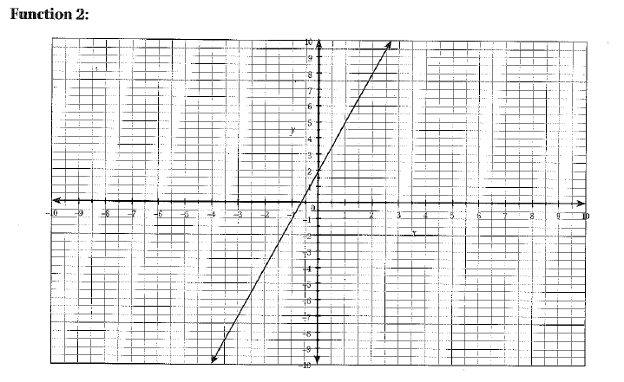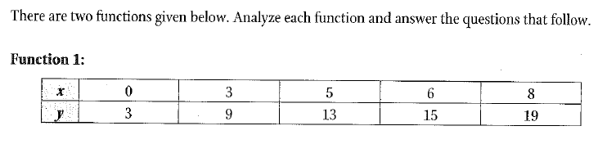STATION 1 NAME_________________________________

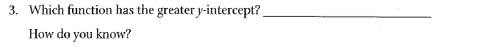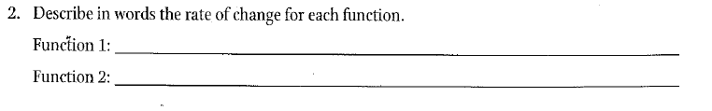

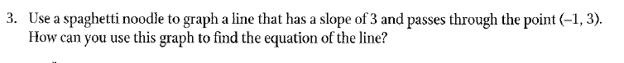

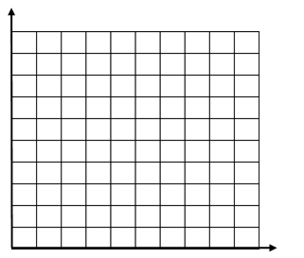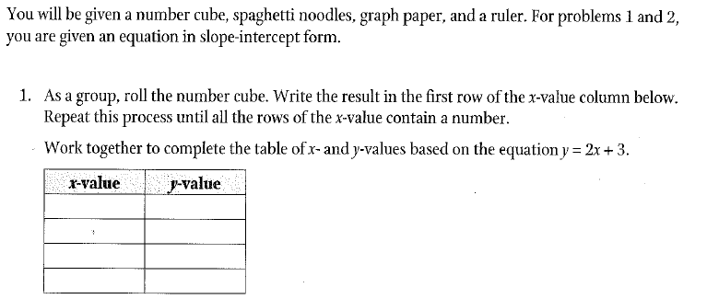STATION 2 NAME_________________________________

2. Graph the data from the table on the grid

at the right.







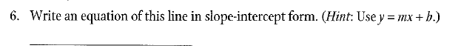

STATION 3 NAME_________________________________

