NAME_____________________________

Midterm Review Sheet

**Directions: Read each question carefully and show all work for full credit.**

***Fill in the table below…***

|  |  |  |
| --- | --- | --- |
| **Fraction** | **Decimal** | **Percent** |
| $$\frac{2}{5}$$ |  |  |
|  | 0.08 |  |
|  |  | 58% |
| $$\frac{1}{3}$$ |  |  |
|  |  | 3% |
|  | 0.781 |  |
|  |  | 400% |

***Evaluate.***

1. 2. 3. 4.

5. 6. 7. 8.

9. 10. 11. 12.

13. 14. 15. 16. -

17. 18.

***Estimate each to the nearest tenths place.***

19. 20. 21.

***Order the following from least to greatest.***

*22. $\sqrt{2}$*, 1.5, 1, 3, $π$, $\sqrt{8}$, 2, 23. 4.5, $\sqrt{9}$, $\sqrt{6}$, 3, $π$, $\sqrt{18}$, 4

***For each of the following state, “rational” or “irrational” and explain why.***

24. 25. 26. 27. 19

28. -38.9 29. 19.168423… 30. 8.16161616… 31. 9.010010001…

***Write each of the following numbers in scientific notation.***

32. 9,260,000,000 33. 0.00061 34. 8.7E-9 35. 65,000

***Write each of the following numbers in standard notation.***

36. 7.1 x 109 37. 1.75 x 10-3 38. 4.813 x 10-7 39. 9.432 x 103

***Simplify completely****.*  ***Where necessary, express your answer using only POSITIVE exponents.***

40. a●a●a●b●b●b●b●b●b 41. a3●b2●a●b6 42. x7●y2●xy3

43. 2x3●3x 44. 32●3 45. 32●52

46.x6●x7 47. x2●y5 48.

49. 50. 51. ●

52. 3053.k054. 5x2y0

55.a1 56. (23)2 57. (x5)4

58. (x5y5)2 59.

***Write using only positive exponents.***

60. x-2 61. 62. 63.

***Fill in the box.***

74. a ● a5 = a8 75. n =

***Write each answer using scientific notation.***

46. 3.2 x 104 + 1.5 x 106 47. 8.4 x 104 - 5.4 x 103

48. 6.2 x 106 ÷ 2.1 x 103 49. 7.4 x 109 ● 1.4 x 103

***Circle the appropriate unit of measure for each of the following…***

50. The average length of a newborn is 43.2 mm / cm / m.

51. An average weight of a newborn is 3.2 mg / g / kg

52. Find the slope for each of the following.

a. y = 2x – 7 b. y = -x – 6

|  |  |
| --- | --- |
| x | y |
| 2 | 4 |
| 4 | 2 |
| 6 | 0 |
| 8 | -2 |

c. d.

|  |  |
| --- | --- |
| x | y |
| -12 | 10 |
| -9 | 1 |
| -6 | -8 |
| -3 | -17 |

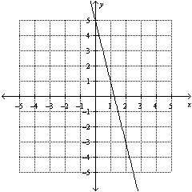e. f.

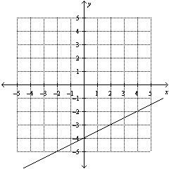

g. (2, -1) (8, 4) h. (4, 10) (10, 12) i. (-6, -4) (6, 1)

1. Write a linear equation for each of the following…

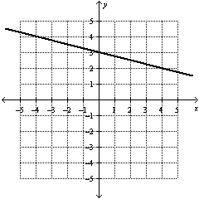a. b.

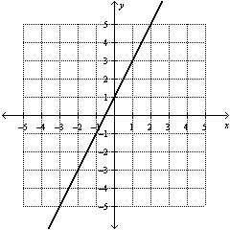

c. d.

|  |  |
| --- | --- |
| x | y |
| -3 | 12 |
| 0 | 24 |
| 3 | 36 |
| 6 | 48 |
| 9 | 60 |

|  |  |
| --- | --- |
| x | y |
| 2 | 16 |
| 4 | 8 |
| 6 | 0 |
| 8 | -8 |
| 10 | -16 |

1. Graph each of the following lines…

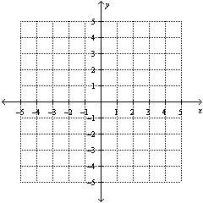a. y = 3x – 5 b. y = ¼x + 2



1. The golf club is looking for new members. There are currently 6 students in the club, but every day three more people sign up.
2. Identify the input and the output for the situation and create a table.

Input: __________________ Output: ______________________

|  |  |  |  |  |  |
| --- | --- | --- | --- | --- | --- |
| Input: |  |  |  |  |  |
| Output: |  |  |  |  |  |

1. Draw a graph of the situation. Be sure to label each axis.

c. Write a linear equation that represents the situation. __________________

1. **Use the equation** you wrote in part c to answer each of the following…
   1. How many students are in the club after 4 days?
   2. If there are 27 people in the club, how many days have gone by?
2. What is the *slope* of this situation? What is the *y-intercept* of this situation?
3. Write the *equation* for the line that goes through each pair of points listed below…
   1. (9, 10) and (3, -2) b. (-1, -5) and (6, -10)
4. Two men are climbing a mountain.

Ted: Ross:

|  |  |
| --- | --- |
| Minutes | Height (ft) |
| 0 | 200 |
| 5 | 240 |
| 10 | 280 |
| 15 | 320 |



* 1. Who is climbing faster?
  2. Who starts out higher on the mountain?
  3. Write an equation for each climber.
     1. Ted: ___________________
     2. Ross: ___________________

1. Solve the equations…

a. x – 2 = 12 b. -3.7 + x = 8 c. -3x = 27 d. = -9



e. 4x – 9 = 19 f. 3 – x = 43 g. - 2 = 3 h. + 2 = 7



i. 3(x – 6) = 8 j. - (4x + 8) = 9 k. 4x + 5x = 18

l. 6x – 8.2 – 3x = 2 m. 7x – 2 + 3x + 6 = 84 n. 4(x – 2) + 3x = 14

1. o. 2x – 8 = 5x + 8 p. 14.5x + 2 = 4.5x + 18 q. 6x – 6 = 2x – 8
2. 3x – 2 + x = 5x s. 3(x – 4) = 5x t. 4x – 1 + 3x = 6x – 3x

59. For a-f, identify if the scatter plot has a positive association, negative association, or no association.

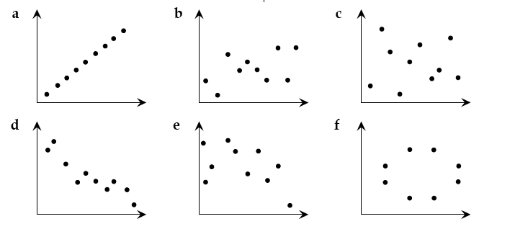

60. What is an outlier? Include a sketch of a graph to help illustrate your explanation.

For 61-68, use the table below. The table represents an item that is sold at the local store. It compares the price of the item and how many items were sold when it was listed at that price.

|  |  |
| --- | --- |
| Price | Quantity Sold |
| 1 | 68 |
| 1.20 | 68 |
| 5.10 | 10 |
| 4 | 26 |
| 3 | 41 |
| 4 | 26 |
| 2.10 | 56 |
| 1.40 | 49 |
| 4.50 | 11 |
| 2.70 | 60 |



Label: _______________

Label: _______________

61. Make a scatter plot of the data. Label both the x–axis and the y–axis.

62. Describe the type of the association between the price of an item and the quantity sold.

63. Draw a trend line that best fits the scatter plot. *Make sure you have arrows on your line.*

64. Write an equation for the line of best fit in Slope–Intercept form

(y = mx + b). Show your work for full credit.

65. In the equation you wrote in #64, the slope, or m = _______.

In the context of the price/quantity situation, this means that...

66. In the equation you wrote in #64, the y-intercept, or b = _______.

In the context of the price/quantity situation, this means that...

67. Using the equation to #64, if 42 customers buy the item, what was it priced at? Show your work for full credit.

68. Using the equation to #64, if an item costs $6, how many customers will buy it? Show your work for full credit.

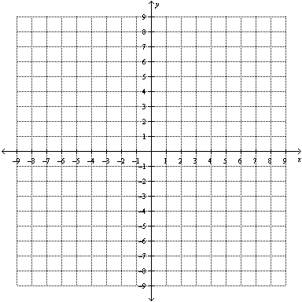69. Solve by graphing.

y = ·x – 2 and y = ·x

70. Solve by substitution.

y = 2x + 5

y = 6x + 1

71. Solve by elimination.

2x+ 3y = 11

-2x + 9y = 1

For numbers 72-79, circle the method that you used. Try to use each method at least once. (Note: You only need to use the graphing grids for the problems that you choose to solve by graphing.)



72. graphing substitution elimination

7x + 2y = 10

-7x + y = -16



73. graphing substitution elimination

5x + 2y = -9

y = -4x - 12

74. graphing substitution elimination



3x + y = 4

6x + 2y = 8

75. graphing substitution elimination

y = -2x – 3

y = -2x +3

76. graphing substitution elimination

y = -0.5x – 6

y = -6 – ½x

77. graphing substitution elimination

y = 3x – 4

-6x + 2y = -8

78. The student council is planning an ice skating trip. Ice World charges a $150 fee to rent the rink and then they charge an additional $5 for each student that comes. Rink-a-Rama charges a $300 fee to rent the rink and then an additional $2 for each student that comes. For what number of students, would the rinks cost the same price?

a. Write a system of linear equations.

b. Solve the system to answer the question.

1. My solution means that…

79. There are 340 animals on a Bill’s farm. Some are sheep and some are chickens. If there are a total of 940 legs among the animals, how many of the animals are sheep and how many are chickens?

a. Write a system of linear equations.

b. Solve the system to answer the question.

1. My solution means that…

80. For each of the following, determine how many solutions the system will have, without graphing or solving. Explain how you know.

1. y = ½ x - 3

y = 0.5x – 4

1. -3x + y = 8

y = 4 + 8x

1. 2x + y = 7

y = -2x + 7

1. 6x + 3y = 12

y = -2x + 2