NAME _______________________________________
More Practice - Scatterplots
The table below represents the relationship between the number of minutes a player played in a basketball game and the number of points that they scored.
- Label each axis.
- Scale the Graph.
- Draw the line of best fit.
- Write an equation for your line of best fit.
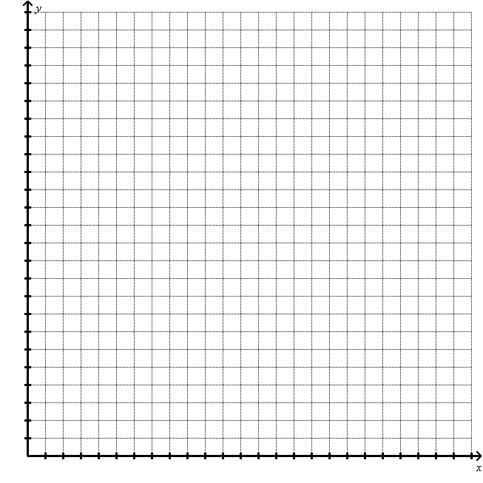
X  Time | Y  # of points
37 | 22
0 | 0
10 | 4
6 | 2
32 | 10  Label: __________
15 | 4
34 | 15
20 | 4
4 | 1
33 | 8
30 | 9
16 | 3

Label: __________

Slope: y-intercept: Equation:

