NAME_________________________
Non Linear
Create examples of each of the following…
Linear
x | y
Graph: Table:

Equation: Situation:

Non - Linear
Graph: Table:

Equation: Situation:

A square tile has side length of x inches. The equation y = x² gives
the area y of the tile in square inches.
y = x²

x

- Do you think that y = x² will produce a graph that is a straight line (linear)? Why or why not?

- Complete the table.
Side Length, x | 1 | 2 | 3 | 4
Area, y

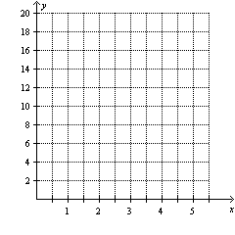
- Plot the points, and then connect the points to represent all the possible x-values and their corresponding y-values.

- Decide whether the equation y = x² is a
linear equation. Explain.

- How is the equation, y = x² different from the linear equations you have graphed?

- Explain whether you think the equation y = 2x² + 4 is a linear equation.

- Error Analysis A student graphed several solutions of y = -2x as shown. The student concluded that the equation is not a linear equation. Explain the student’s error.
(copy and paste graph from On core p. 41.)

Copy and paste “practice” from on core p. 42.

