Review: Rates, Ratios, & Proportions NAME__________________________
Directions:
- Round all answers to the nearest tenth, except when the answer is representing money!
Use the graph below to answer the following questions…
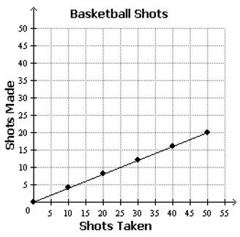

- Which of the following statements describe the graph? Select all that apply.

    - If 25 shots were taken, 10 were made.
    - If 20 shots were made, 40 were taken.
    - If 0 shots were taken, 0 shots were made.
    - If 20 shots are taken, less than 10 will be made.
    - If 30 shots are taken, more than 15 shots will be made.

- Select the statement about the graph that is not true.

    - The point (0, 0) shows that 0 shots taken results in 0 shots made.
    - The point (50, 20) shows that 20 shots taken results in 50 shots made.
    - The point (40, 16) shows that if 40 shots are taken, 16 are made.

- Select all of the ordered pairs that would also lie on the line above?

    - (60, 30)
    - (75, 30)
    - (100, 50)
    - (100, 40)

- If 125 shots are taken, that means that _________ shots will be made.

- For each of the following…
  - Circle whether it is proportional or not.
  - If they are proportional find the unit rate (Be sure to include units if you can).
  - If they are proportional, write the equation.

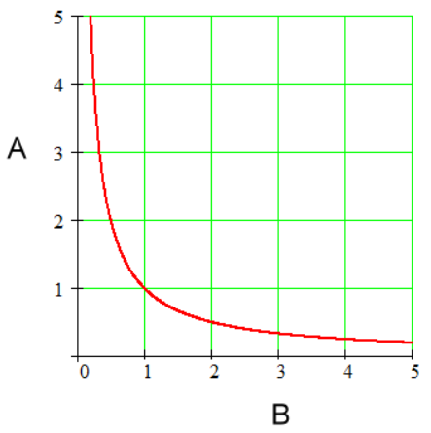
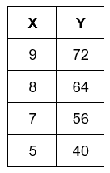
  - Proportional or NOT? b. Proportional or NOT?

Unit Rate: _________ Unit Rate: __________
Equation: _______________ Equation: _______________

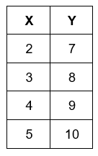
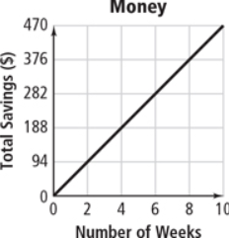
c. Proportional or NOT? d. Proportional or NOT?

Unit Rate: _________ Unit Rate: __________
Equation: _______________ Equation: _______________

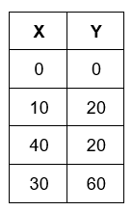
e. Proportional or NOT? f. Proportional or NOT?
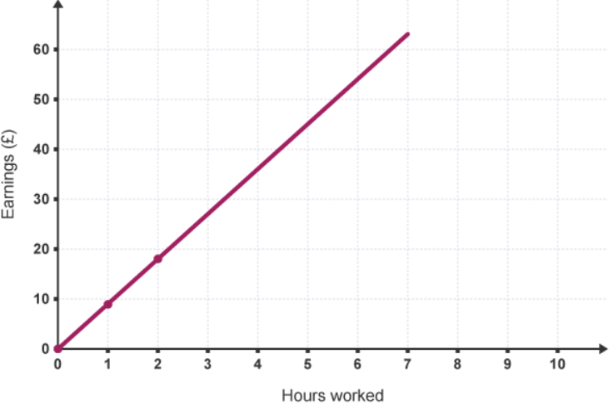

Unit Rate: _________ Unit Rate: __________
Equation: _______________ Equation: _______________

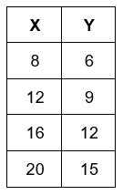
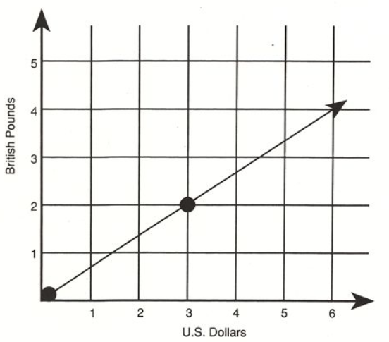
g. Proportional or NOT? h. Proportional or NOT?

Unit Rate: _________ Unit Rate: __________
Equation: _______________ Equation: _______________

- Determine whether or not each of the following is a proportion. Show evidence to support your answer.
  - $\frac{2}{3}= \frac{12}{18}$ b. $\frac{4}{5}= \frac{8}{12}$ c. $\frac{6}{7}= \frac{3}{4}$

- Solve each of the proportions below…
  - $\frac{x}{3}= \frac{5}{6}$ b. $\frac{4}{7}= \frac{x}{12}$ c. $\frac{2}{7}= \frac{3}{x}$

d. e. f.

For each of the following, write a proportion and then solve.
- According to the label there are 215 calories in a Snickers candy bar. How many calories are there in 6 candy bars?

Proportion

- Clarence paid $3.21 in tax for 5 hats. At this rate, what would the tax be if he bought 3 hats?

Proportion

- DeMarius drove 190 miles in 3 hours. At that rate, how long would it take DeMarius to drive 320 miles?

Proportion

- Alicia is making cupcakes for a party she is having and wants to make sure everyone gets at least one cupcake. The recipe calls for ½ of a teaspoon of salt for every batch (21 cupcakes). If Alicia is having a party with 84 people attending, how many teaspoons of salt will Alicia use?

Proportion

- Dominique walks $\frac{3}{5}$ of a mile in $\frac{1}{4}$ of an hour. Her friend, Melissa, walks for $\frac{2}{3}$ of an hour. Melissa states that she walked x miles and walked at the same rate as Dominique. What value of x would make Melissa’s statement true?

Proportion

- A mixture of paint calls for $\frac{3}{5}$ of a cup of red paint and $\frac{4}{5}$ cups of yellow paint. How many cups of red paint would be needed for every 1 cup of yellow paint?

Proportion

- Xavier decided to run $3\frac{1}{4}$ miles after school. He runs at a pace of 8$\frac{1}{2}$ miles per hour. How long will it take Xavier to do the run?

Proportion

Use the chart below to convert the following units…
Conversions
1 hour = 3600 seconds 1 mile = 5280 feet 1 yard = 3 feet
1 meter = 3.28 feet 1 km = 0.62 miles 1 kg = 2.2 lbs
1 quart = 0.946 liters 1 foot = 12 inches
1 inch = 2.54 cm = 25.4 mm 16 oz = 1 lb
- 3005 feet into miles 16. 65 kilograms into pounds

17. 59 cm into inches 18. 148 ounces into pounds

19. How many meters in 0.75 miles? 20. 4 gal = ________ oz

21. 42 km/hr = ________ ft/s

Solve each problem below.

- A toy manufacturer is going to produce a toy that is a scale model of the giant robot in a super hero movie, where 1 cm = 6 feet. If the robot in the movie was 36 feet tall, what will be the height of the toy?

- Matthew bought a scale model toy version of the space ship in his favorite science fiction television show. If the toy is constructed with the scale 1 inch = 12 feet and the toy is 1 foot 4 inches long, how long is the ship in the television show?

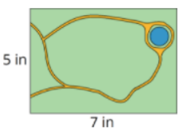
- A scale drawing of a rectangular park is 5 inches wide and 7 inches long. The actual park is 140 yards long. What is the width of the actual park?

- A scale replica of a school is pictured below. If the actual school is 32 yards long, what is the actual height of the school?
7 in

5 in

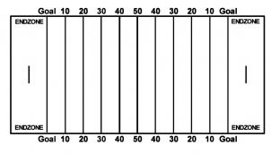
2.22 yds
- A coach created a scale model of a football field for his players and it is pictured below. If the image is scaled by a factor of 24, what are the actual width and length of a football field?
5 yd.

- For each of the following…
  - Tell whether each pair of polygons is similar.
  - Explain why or why not.
  - If they are similar, find the scale factor of the triangle on the left to the one on the right.

3 3 4 8 14 9 9 8

5
2
6 10

28.) A telephone booth 7 ft tall cast a shadow 20 ft long. At the same time, a nearby fire hydrant casts a shadow 8 ft. long. Find the height of the fire hydrant. Show all work.

29) You decide you want to find out how many deer are in your woods in your back yard. You tag 345 deer and release them back in the wild. A month later, you collect a sample of 980 deer, 120 of which are tagged. Estimate the total deer population in that area.

30) The triangles are similar. Find x, y and z.
x = __________

y = __________
x
15 ft 17 ft z = __________
z
y 31°
21 ft 14 ft

31) The triangles are similar. Find x and y.

- b)
15
y
y x
12
x 7 4

26 28 6 9

x = _______ x = _______

y = _______ y = _______

32) What is the relationship between the area scale factor and the side length scale factor of similar figures?

33) Find the missing area in each pair of similar figures below…

- b)

3 ft. 6 ft.
6 cm 2 cm

Area = 81 cm² Area = ? Area = 6 ft² Area = ?

ANSWERS

- A, C, D
- B
- B, D
- 50 shots made
- A. Proportional, 8, y = 8x
B. NOT
C. Proportional, $\frac{\$47}{week}$, y = 47x
D. NOT
E. NOT
F. Proportional, $\frac{\$10}{hr}$, y = 10x
G. Proportional, $\frac{2 lbs}{\$3}$, y = $\frac{2}{3}$x
H. Proportional, $\frac{3}{4}$, y = $\frac{3}{4}$x
6. A. Yes
B. NO
C. NO
7. A. 2 ½ or 2.5
B. $6\frac{6}{7}$ or 6.9
C. 10 ½ or 10.5
D. 14
E. $-3\frac{2}{3}$
F. -19
8. 1290 calories
9. $1.93
10. 5.1 hours
11. 2 tsp
12. 1$\frac{3}{5}$ or 1.6
13. $\frac{3}{4}$ cup or 0.75 cups
14. $\frac{13}{34}$ hrs or 0.4 hours
15. 0.6 miles
16. 143 lbs
17. 23.2 inches
18. 9.3 lbs
19. 1207.3 meters
20. 140.8 oz
21. 38.2ft/sec
22. 6 cm
23. 192 ft.
24. 100 yds
25. 44.8 yds
26. Length = 120 yards, Width = 53.3 yards
27. a. 1. Yes, 2. they have the same angles and their side lengths are proportional, 3. 3
b. 1. No 2. The side lengths are NOT proportional.
28. 2.8 ft.
29. 2817.5 deer
30. x = 25.5, y = 31, z = 10ft
31. a. x = 32.5, y = 7 b. x = 10, y = 10.5
32. SLSF² = ASF
33. a. 9 cm² b. 24 ft²

