NAME _______________________________________
Scaling - Scale and label each graph below according to the values in the table.
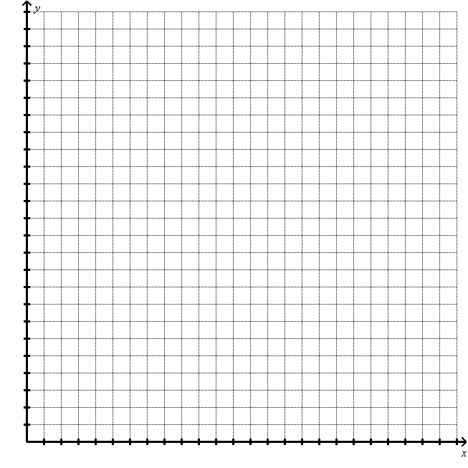
X  # of Roommates | Y  Rent per person
3 | $400
2 | $900
3 | $500
2 | $700
4 | $511  Label: __________

Label: __________

2.
X  Current Age | Y  Life Expectancy
10 | 67.4
15 | 62.5
20 | 57.7
25 | 53.0
30 | 48.2  Label: __________
35 | 43.5
40 | 38.8
45 | 34.3

Label: __________
3.
X  At Bats | Y  Hits
564 | 147
442 | 136
617 | 189
672 | 194
344 | 100  Label: __________
407 | 107
254 | 65

Label: __________

4.
X  # of Farms (millions) | Y  Average Size (acres)
6.3 | 157
6.1 | 175
5.39 | 216
3.96 | 297
2.95 | 373  Label: __________
2.44 | 426
2.15 | 460
2.17 | 434

Label: __________

